Name: __________________________

The Rise of Sumer and Their Achievements

As civilizations developed along rivers, their societies and governments became more advanced. Religion became a main characteristic of these ancient civilizations. Kings claimed to rule with the approval of the gods, and ordinary people wore charms and performed rituals to avoid bad luck.

An Advanced Society

In southern Mesopotamia, a people known as the Sumerians (soo-MER-ee-unz) developed the world’s first civilization. No one knows where they came from or when they moved into the region. However, by 3000 BCE, several hundred thousand Sumerians had settled in Mesopotamia, in a land they called Sumer (soo-muhr). There they created an advanced society.

The City-States of Sumer
Most people in Sumer were farmers. They lived mainly in rural, or countryside, areas. The centers of Sumerian society, however, were the urban, or city, areas. The first cities in Sumer had about 10,000 residents. Over time, the cities grew. Historians think that by 2000 BCE, some of Sumer’s cities had more than 100,000 residents.
As a result, the basic political unit of Sumer combined the two parts. This unit was called a city-state. A city-state (just as a reminder) consisted of a city and all the countryside around it. The amount of countryside controlled by each city-state depended on its military strength. Stronger city-states controlled larger areas.
City-states in Sumer fought each other to gain more farmland. As a result of these conflicts, the city-states built up strong armies. Sumerians also built strong, thick walls around their cities for protection.
Individual city-states gained and lost power over time. By 3500 BCE, a city-state known as Kish had become quite powerful. Over the next 1,000 years, the city-states of Uruk and Ur fought for dominance. Once of Uruk’s kings, known as Gilgamesh, became a legendary figure in Sumerian literature (like Odysseus and Aeneas).

Rise of the Akkadian Empire

In time, another society developed along the Tigris and Euphrates. It was created by the Akkadians (uh-KAY-dee-uhns). They lived just north of Sumer, but they were not Sumerians. They even spoke a different language than the Sumerians. In spite of their differences, however, the Akkadians and the Sumerians lived in peace for many years.

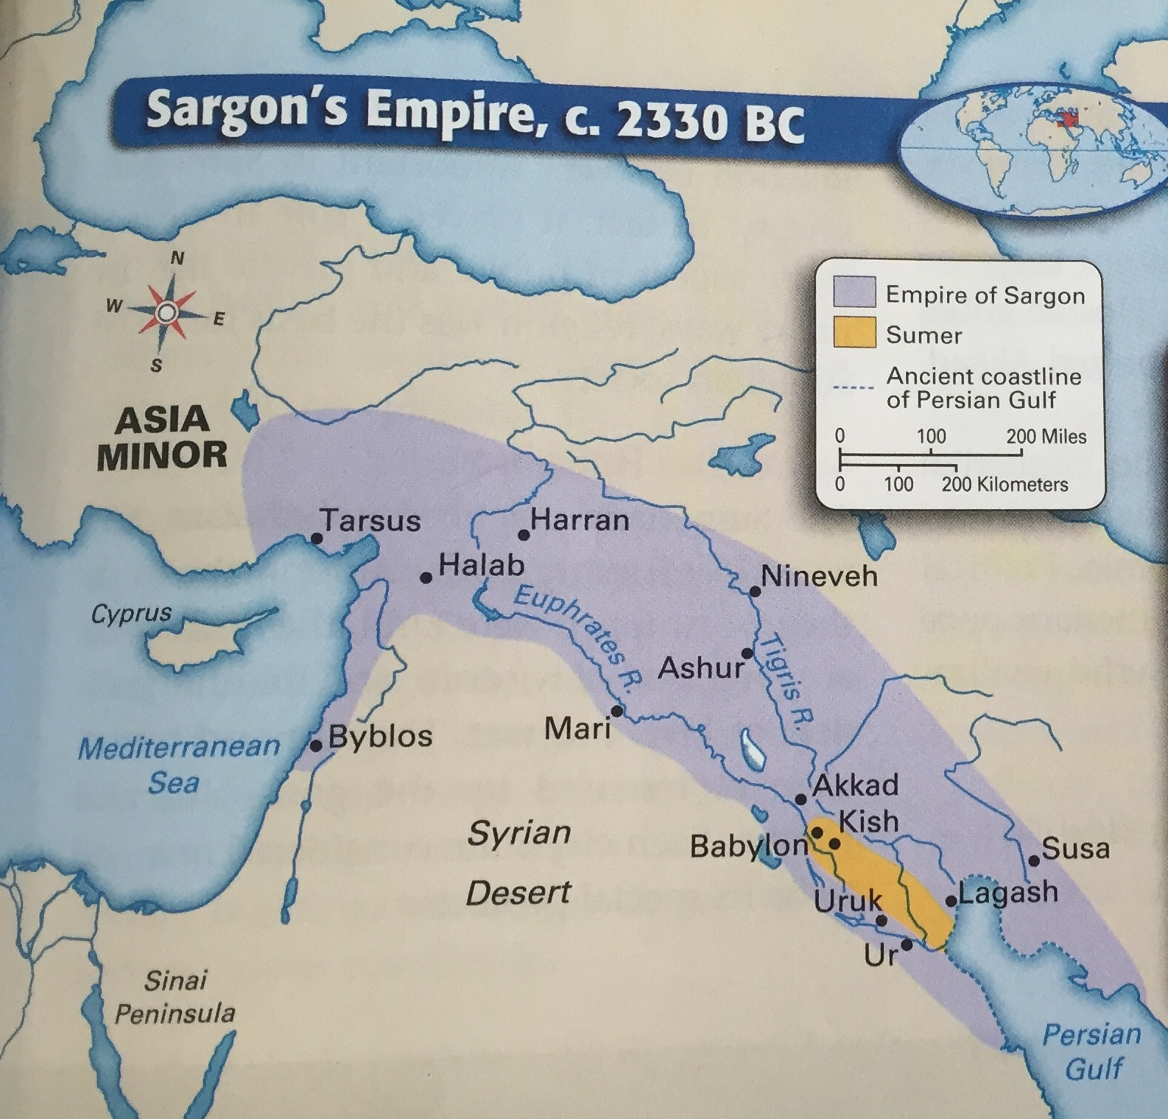

That peace was broken in the 2300s BCE when Sargon sought to extend Akkadian territory. He built a new capital, Akkad (A-kad), on the Euphrates River, near what is now the city Baghdad. Sargon was the first ruler to have a permanent army. He used that army to launch a series of wars against neighboring kingdoms.
Sargon’s soldiers defeated all the city-states of Sumer. They also conquered northern Mesopotamia, finally bringing the entire region under his rule. With these conquests, Sargon established the world’s first empire, or land with different territories and peoples under a single rule. The Akkadian Empire stretched from the Persian Gulf to the Mediterranean Sea.
Sargon was emperor, or ruler of his empire, for more than fifty years. However, the empire lasted only a century after his death. Later rulers could not keep the empire safe from invaders. Hostile tribes from the east raided and captured Akkad. A century of chaos followed.
Eventually, however, the Sumerian city-state of Ur rebuilt its strength and conquered the rest of Mesopotamia. Political stability was restored. The Sumerians once again became the most powerful civilization in the region.

Religion Shapes Society

Religion was very important in Sumerian society. In fact, it played a role in nearly every aspect of public and private life. In many ways, religion was the basis for all of Sumerian society.

Sumerian Religion

The Sumerians practiced polytheism, the worship of many gods. Among the gods they worshipped were Enlil, the lord of the air; Enki, god of wisdom; and Inanna, goddess of love and war. The sun and moon were represented by the gods Utu and Nanna. Each city-state considered one god to be its special protector (sounds like Greece).
The Sumerians believed that their gods had enormous powers. Gods could bring a good harvest or a disastrous flood. They could bring illness, or they could bring good health and wealth. The Sumerians believed that success in every area of life depended on pleasing the gods. Every Sumerian had a duty to serve and to worship the gods.
Priests, people who performed religious ceremonies, had great status in Sumer. People relied on them to help gain the gods’ favor. Priests interpreted the wishes of the gods and made offerings to them.

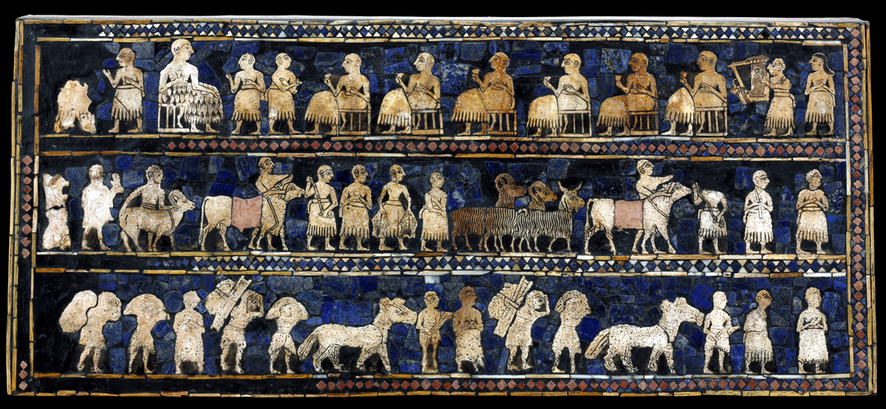
Standard of Ur – Peace Side

Sumerian Social Order

Because of their status, priests occupied high level in Sumer’s social hierarchy, the division of society by rank or class. In fact, priests were just below kings. The kings of Sumer claimed that they had been chosen by the gods to rule (a line kings continued to use throughout history, divine right).
Below the priests were Sumer’s skilled craftspeople, merchants, and traders. Trade had a great impact on Sumerian society. Traders traveled to faraway places and exchanged grain for gold, silver, copper, lumber, and precious stones.
Below traders, farmers and laborers made up the large working class. Slaves were at the bottom of the social order.

Questions:

- What was the basic political unit in Sumer?
- What steps did city-states take to protect themselves from their rivals?
- How do you think Sargon’s creation of an empire changed the history of Mesopotamia? Defend your answer (use evidence).
- Why do you think priests were so influential in ancient Sumerian society?
- Why would rulers benefit if they claimed to be chosen by the gods?
- Create a triangle showing the social hierarchy of Sumerian society.

Sumerian Achievements

Sumerian society was advanced in terms of religion and government organization. The Sumerians were responsible for many other achievements, which were passed down to later civilizations.

The Invention of Writing

The Sumerians made on of the greatest cultural advances in history. The developed cuneiform (kyoo-NEE-uh-fohrm), the world’s first system of writing. But Sumerians did not have pencils, pens, or paper. Instead, they used sharp tools called styluses to make wedge-shaped symbols on clay tablets.
Earlier written communication had used pictographs, or picture symbols. Each pictograph represented an object, such as a tree or an animal. But in cuneiform, symbols could also represent syllables, or basic parts of words. As a result, Sumerian writers could combine symbols to express more complex ideas such as “joy” or “powerful.”

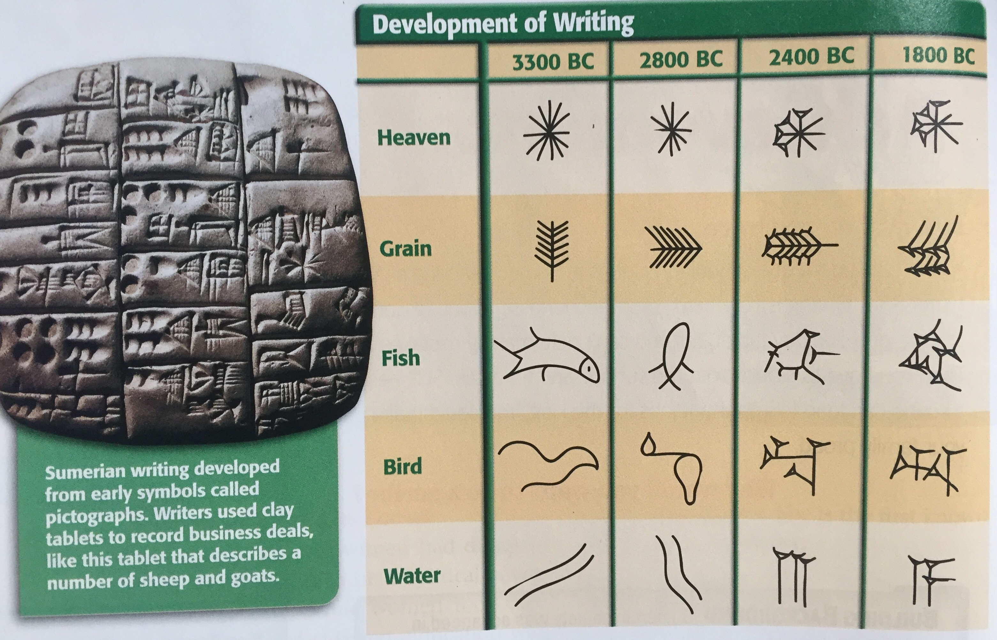
Development of Sumerian Writing

Sumerians fist used cuneiform to keep business records. A scribe, or writer, would be hired to keep track of the items people traded. Government officials and temples also hired scribes to keep their records. Becoming a scribe was a way to move up in social class.
In time, Sumerians put their writing skills to new uses. They wrote works on history, law, grammar, and math. They also created works of literature. Sumerians wrote stories, proverbs, and songs. They wrote poems about the gods and about military victories. Some of these were epics, long poems that tell the stories of heroes. Later, people used some of these poems to create The Epic of Gilgamesh (there is that epic poem again), the story of a legendary Sumerian king.

Advances and Inventions

Writing was not the only great Sumerian invention. These early people made many other advances and discoveries.

Technical Advances

One of the Sumerian’s most important developments was the wheel. They were the first people to build wheeled vehicles, including carts and wagons. Using the wheel, Sumerians invented a device that spins clay as a craftsperson shapes it into bowls. This device is called a potter’s wheel (still used today).
The plow was another important Sumerian invention. Pulled by oxen, plows broke through the hard clay soil of Sumer to prepare it for planting. This technique greatly increased farm production. The Sumerians also invented a clock that used falling water to measure time.

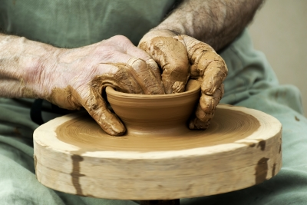
Potter’s Wheel

Sumerian advances improved daily life in many ways. Sumerians built sewers under city streets. They learned to use bronze to make stronger tools and weapons. They even produced makeup and glass jewelry.

Math and Sciences

Another area in which Sumerians excelled was math. In fact, they developed a math system based on the number 60. Based on this system, they divided a circle into 360 degrees. Dividing a year into 12 months – a factor of 60 – was another Sumerian idea. Sumerians also calculated the areas of rectangles and triangles.
Sumerian scholars studied science, too. They wrote long lists to record their study of the natural world. These tablets included the names of thousands on animals, plants, and minerals.
The Sumerians also made advances in medicine. They used ingredients from animals, plants, and minerals to produce healing drugs. Items used in these medicines included milk, turtle shells, figs, and salt. The Sumerians even catalogued their medical knowledge, listing treatments according to symptoms and body parts.

The Arts of Sumer

The Sumerians’ skills in the fields of art, metalwork, and architecture are well known to us. The ruins of great buildings and fine works of art have provided us wonderful examples of the Sumerians’ creativity.

Architecture

Most Sumerian rulers lived in large palaces. Other rich Sumerians had two-story homes
with as many as a dozen rooms. Most people, however, lived in smaller, one-story houses. These homes had six or seven rooms arranged around a small courtyard. Large and small houses stood side by side along the narrow, unpaved streets of the city. Bricks made of mud were the houses’ main building blocks.
City centers were dominated by their temples, the largest and most impressive buildings in Sumer. A ziggurat, a pyramid-shaped temple tower, rose above each city. Outdoor staircases led to a platform and a shrine at the top. Some architects added columns to make the temples more attractive (do you still remember the three Greek column styles?)

The Arts

Sumerian sculptors produced many fine works. Among them are the statues of gods created for temples. Sumerian artists also sculpted small objects out of ivory and rare woods. Sumerian pottery is known more for its quantity than quality. Potters turned out many items, but few were works of beauty.
Jewelry was a popular item in Sumer. The jewelers of the region made many beautiful works out of imported gold, silver, and gems. Earrings and other items found in the region show that Sumerian jewelers knew advanced methods for putting gold pieces together.

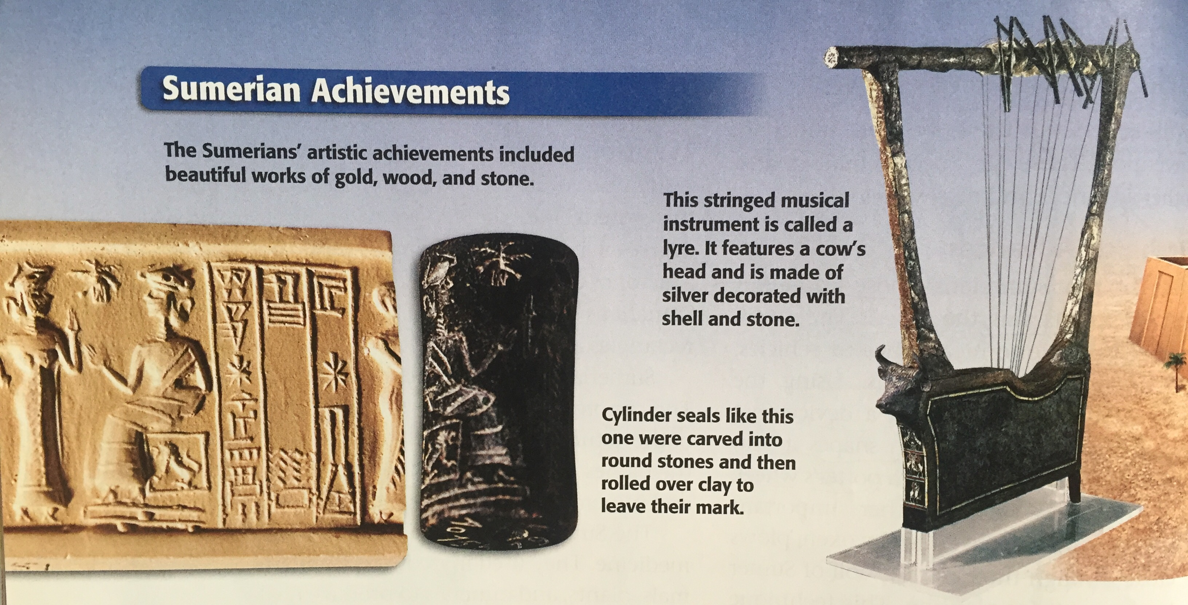
Sumerian Achievements including: cylinder seals (left) and bull-headed lyre (right)

Cylinder seals are perhaps Sumer’s most famous works of art. These small objects were stone cylinders engraved with designs. When rolled over clay, the designs would leave behind their imprint. Each seal left its own distinct imprint. As a result, a person could show ownership of a container by rolling a cylinder over the container’s wet clay surface. People could also use cylinder seals to “sign” documents or to decorate other clay objects.
Some seals showed battle scenes. Others displayed worship rituals. Some were highly decorative, with hundreds of carefully cut gems. They required great skill to make.
The Sumerians also enjoyed music. Kings and temples hired musicians to play on special occasions. Sumerian musicians played on reed pipes, drums, tambourines, and stringed instruments called lyres. Children learned songs in school. People sang hymns to gods and kings. Music and dance provided entertainment in marketplaces and homes.

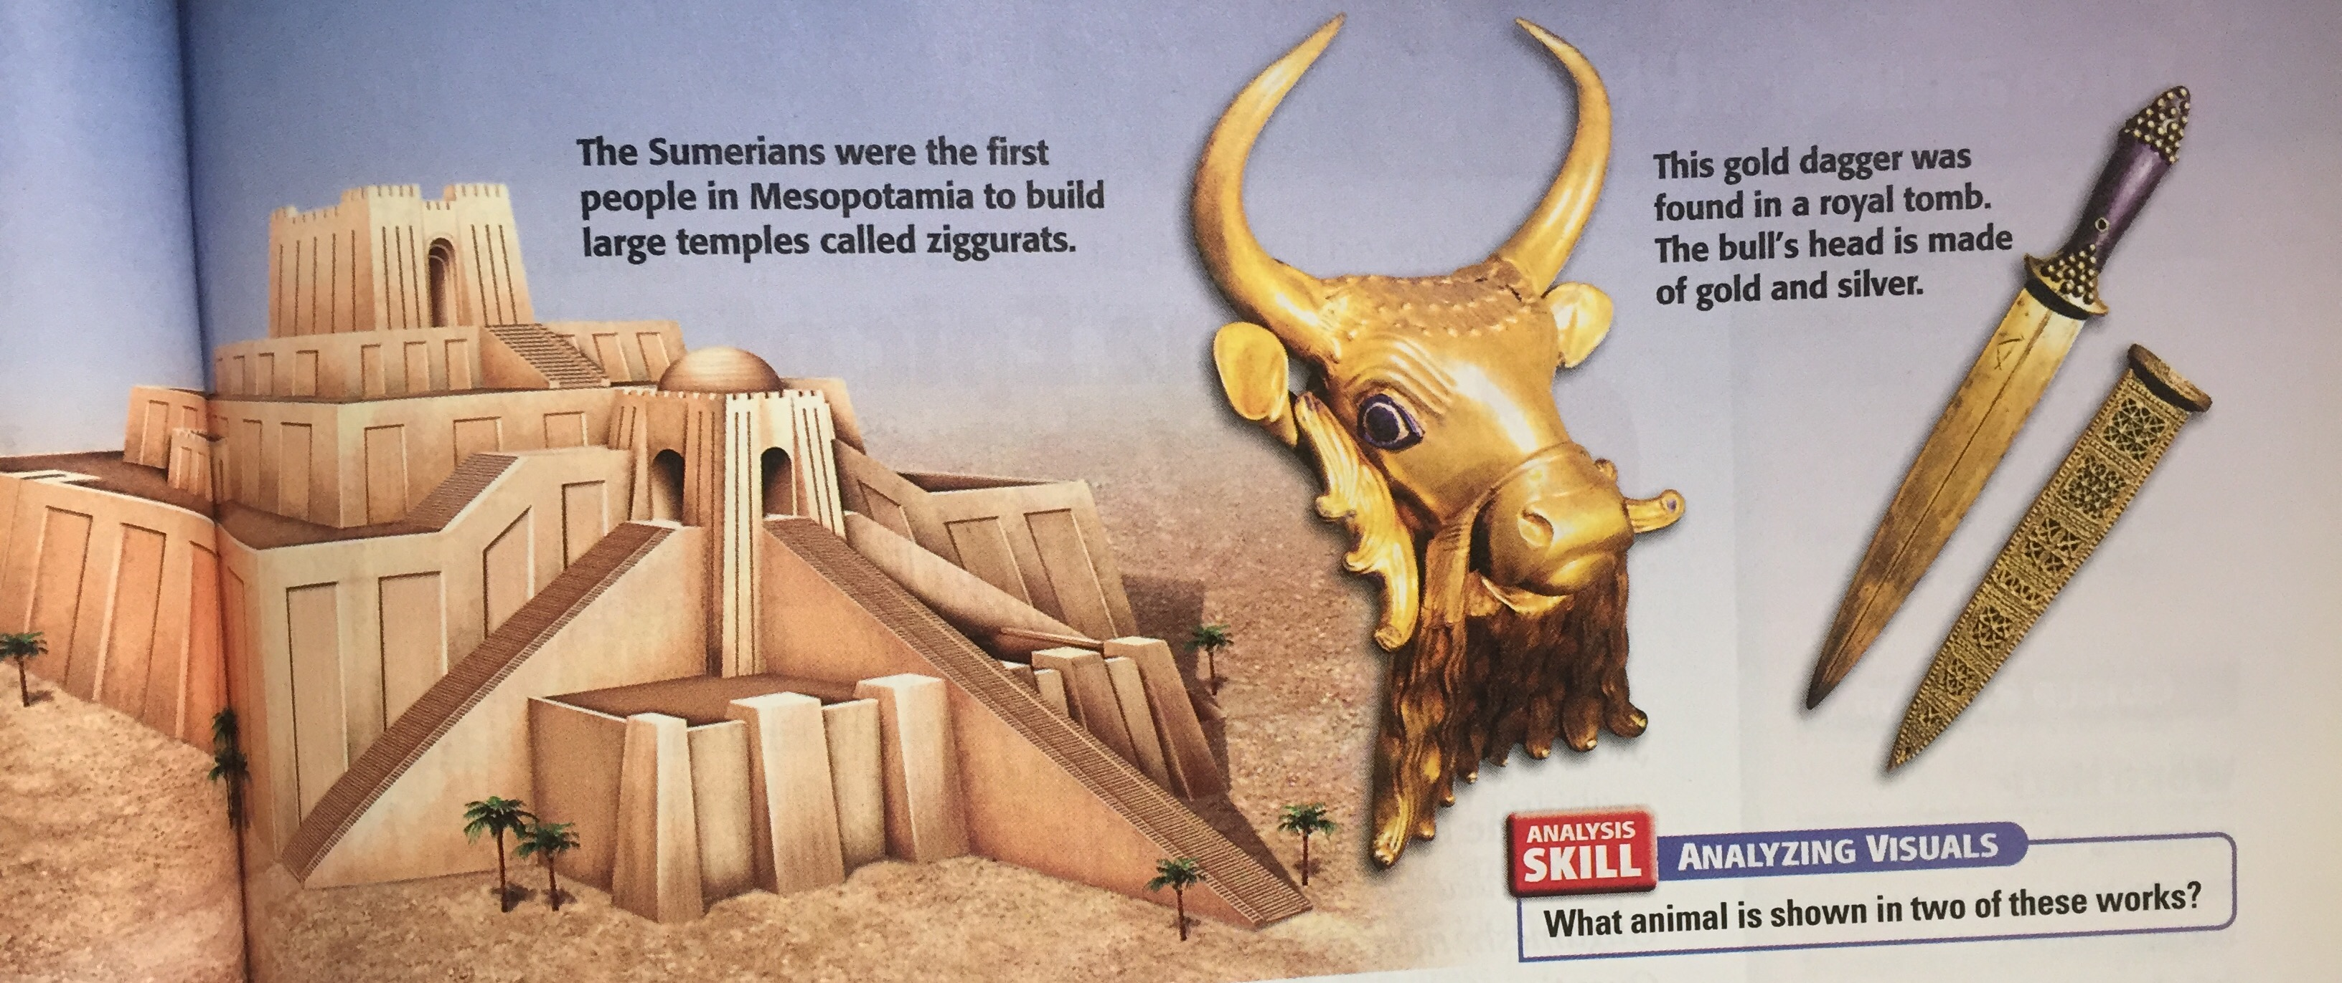
Picture of ziggurat and Sumerian craftsmanship

Questions:

- What is cuneiform?
- Why do you think writing is one of history’s most important cultural advances?
- What current leader would you choose to write an epic about, and why?
- Why do you think the invention of the plow was so important to the Sumerians?
- Why do you think cylinder seals developed into works of art?

