Rome’s Legacy

Roman Science and Engineering

The Romans took a practical approach to their study of science and engineering. Unlike the Greeks, who studied the world just to now about it, the Romans were more concerned with finding knowledge that they could use to improve their lives.

Science

Roman scientists wanted to produce results that could benefit their society. For example, they studied the stars not just to know about them but also to produce a calendar. They studied plants and animals to learn how to produce better crops and meat.

The practical Roman approach to science can also be seen in medicine. Most of the greatest doctors in the Roman Empire were Greek. One doctor in the empire was Galen, who lived in the second century CE. He was a Greek surgeon who made many discoveries about the body. For example, Galen described the valves of the heart and noted differences between arteries and veins. For centuries, doctors based their ideas on Galen’s teachings and writings.

Engineering

The Roman’s practical use of science can also be seen in their engineering. The Romans were great builders. Even today people walk along Roman roads and drive over Roman bridges built almost 2,000 years ago. How have these structures survived for so long?
Name: ___________________________________

The Romans developed some new building materials to help their structures last. The most important of these materials was cement. They made cement by mixing a mineral called lime with volcanic rock and ash. The resulting material dried to be very hard and watertight.

More important than the materials they used, though, were the designs the Romans had for their structures. For example, they built their roads in layers. Each layer was made of a different material. This layered construction made the road durable. Many Roman roads have not worn down even after centuries of traffic and exposure to wind and rain.

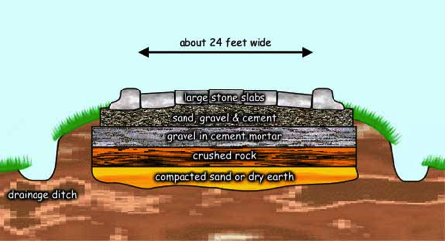

Another way the Romans created structures to last was by using arches. Because of its rounded shape, an arch can support much heavier weights than other shapes can. This strength has allowed arched structures such as Roman bridges to last until the present.

The Romans also used arches in their aqueducts. An aqueduct was a channel used to carry water from mountains into cities. When they crossed deep valleys, aqueducts were supported by rows of arches. The Romans’ aqueducts were so well built that many still stand.

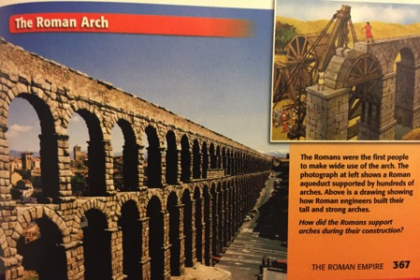
Answer: The Roman arch was supported with a wooden form that supported the arch’s weight.

Roman builders also learned how to combine arches to create vaults. A vault is a set of arches that supports the roof of a building. The Romans used vaults to create huge, open areas within buildings. As a result, Roman buildings were much larger than anything that had come before.

Architecture and Art

The Romans weren’t only interested in practicality, though. They also admired beauty. Roman appreciation for beauty can be seen in their architecture and art. People still admire their magnificent buildings, statues, and paintings.

Architecture

Roman architecture was largely based on older Greek designs. Like the ancient Greeks, the Romans used columns to make their public buildings look stately and impressive. Also like the Greeks, the Romans covered many of their buildings with marble to make them more majestic.

But Roman engineering techniques allowed them to take architecture beyond what the Greeks had done. For example, the Roman vault let them build huge structures, much larger than anything the Greeks could build. One such Roman structure that used vaults was the Coliseum. It was built to hold fights between gladiators.

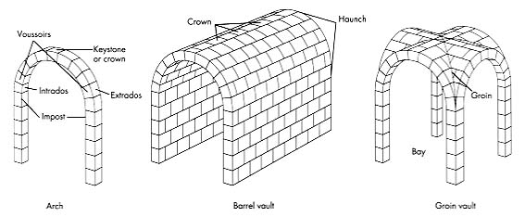

The Romans also used more domes in their architecture than the Greeks had. Domes were difficult to build and required a great deal of support. Once the Romans developed cement, they could provide that support. Many Roman structures are topped with huge domes, some of the largest ever built.

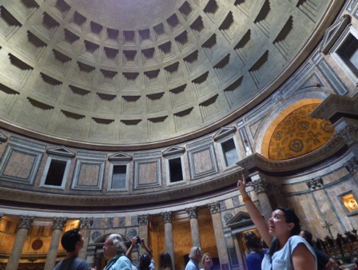
Ms. Lauren inside the Pantheo, which has one of the most awesome domes in Rome!

Art

The artists of the Roman Empire were known for their beautiful mosaics, paintings, and statues. Mosaics and paintings were used to decorate Roman buildings. Many Roman homes and businesses had elaborate mosaics built into their floors. The walls of these buildings were often covered with paintings. Most Roman paintings were frescoes. A fresco is a type of painting done on wet plaster.

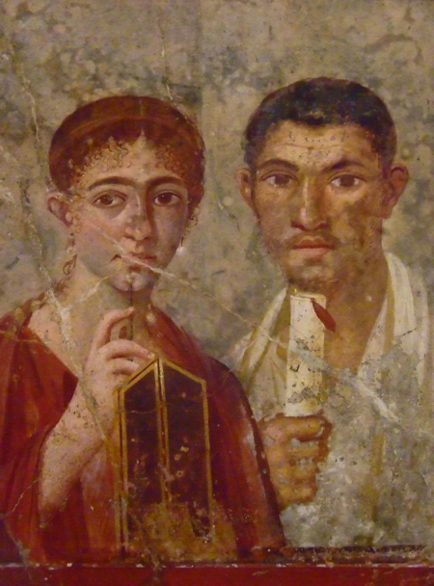
Roman Fresco circa 60CE. Found in Pompey.

Many Roman artists were particularly skilled at creating portraits, or pictures of people. When they made a portrait, artists tried to show their subject’s personality. We can guess a great deal about individual Romans by studying their portraits.

Roman sculptors were also talented. They created some original works, but many Roman statues are actually copies of older Greek works. Roman sculptors studied what the Greeks had done and tried to re-create it in their own statues. Although their works are not original, we owe a great deal to these Roman artists. Many of the original Greek works they copied have been destroyed over time. Without the Roman copies, the world would know little about many Greek masterpieces.

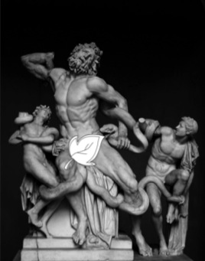
Laocoon and his Sons from the Aeneid. Visit this statue at the Museum in Vatican City (The Pope’s Museum)

Literature and Language

Like Roman artists, Roman authors are greatly admired. In addition, the works they created and the language they used have shaped our language today.

Literature

The Romans admired good writers. Many emperors encouraged authors to write. As a result, Rome was home to many of the greatest authors of the ancient world. One such author was Virgil, who wrote a great epic about the founding of Rome, the Aeneid. Another was Ovid (AHV-uhd), who wrote poems about Roman mythology.

The Romans also excelled in other types of writing:
- Satire, a style of writing that pokes fun at people or society
- History and speeches
- Drama, both tragedies and comedies
Many of these works have served as models for hundreds of years and are still enjoyed today.

Language

Virgil, Ovid, and other poets wrote in Latin, the language of ancient Rome. The Roman Empire was huge, and it had two official languages. In the east, some people spoke Greek. People throughout the western Roman world wrote, conducted business, and kept records in Latin. This wide use of Latin helped tie people in various parts of the empire together.

After the Roman Empire ended, Latin developed into many different languages. Together, the languages that developed from Latin are called Romance languages. The main Romance languages are Italian, French, Spanish, Portuguese, and Romanian. They share many elements with each other and with Latin.

Over time, Latin also influenced other languages. For example, many Latin words entered non-Romance languages, including English. Words like et cetera, circus, and veto were all originally Latin terms. Latin words are also common in scientific terms and mottoes. For example, the motto of the United States in the Latin phrase e pluribus unum (ee PLOOHR-uh-buhs OO-nuhm), which means “out of many, one.”

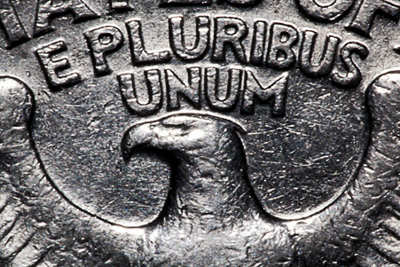

Please answer the following questions on a separate piece of paper (you can type them if you would like). Remember to use complete sentences

- What is an example of an important medical discovery during the Roman Empire?
- Show on a timeline when Galen was alive.
- Why was cement such an important part of Roman engineering?
- What was cement made of?
- How were Romans able to increase the size of their buildings?
- What architecturals features were used more on Roman buildings than Greek ones?
- Why should we thank the Romans for being copycats with their statue designs?
- Who were two great Roman writers?
- Why did the Roman Empire have two official languages?
- How has Latin influenced present-day European and American languages?
- Extra Credit: What do you think the symbolism of “out of many, one” represents?

