Name: ___________________________

Geography and the Fertile Crescent

In several parts of the world, bands of hunter-gatherers began to settle down in farming settlements. They domesticated plants and animals. Gradually their cultures became more complex. Most early civilizations grew up along rivers, where people learned to work together to control floods.

Rivers Support the Growth of Civilization

Early peoples settled where crops would grow. Crops usually grew well near rivers, where water was available and regular floods made the soil rich. One region in Southwest Asia was especially well suited for farming. It lay between two rivers.

The Land Between the Rivers

The Tigris and Euphrates rivers are the most important physical features of the region sometimes known as Mesopotamia (mes-uh-puh-TAY-mee-uh). Mesopotamia means “between the rivers” in Greek.
As you can see on the map, the region called Mesopotamia lies between Asia Minor and the Persian Gulf. The region is part of a larger area called the Fertile Crescent, a large arc of rich, or fertile, farmland. The Fertile Crescent extends from the Persian Gulf to the Mediterranean Sea.

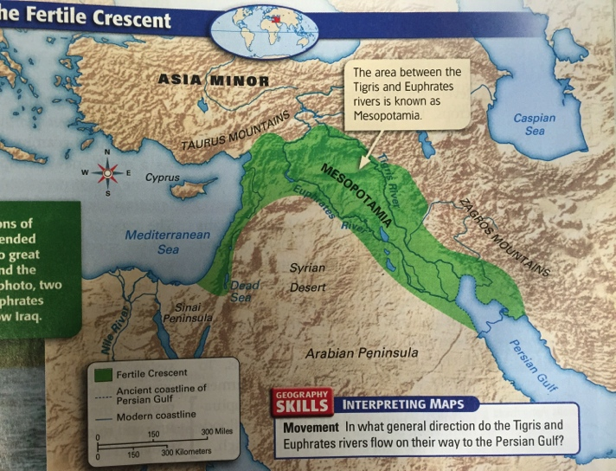

In ancient times, Mesopotamia was actually made of two parts. Northern Mesopotamia was a plateau bordered on the north and east by mountains. Southern Mesopotamia was a flat plain. The Tigris and Euphrates rivers flowed down from the hills into this low-lying plain.

The Rise of Civilization

Hunter-gatherer groups first settled in Mesopotamia more than 12,000 years ago. Over time, these people learned how to plant crops to grow their own food. Every year, floods on the Tigris and Euphrates rivers brought silt, a mixture of rich soil and tiny rocks, to the land. The fertile silt made the land ideal for farming.
The first farm settlements formed in Mesopotamia as early as 7000 BCE. Farmers grew wheat, barley and other types of grain. Livestock, birds, and fish were also good sources of food. Plentiful food led to population growth, and villagers formed. Eventually, these early villagers developed into the world’s first civilization.

Farming and Cities

Although Mesopotamia had fertile soil, farming wasn’t easy there. The region received little rain. This meant that the water levels in the Tigris and Euphrates rivers depended on how much rain fell there, water levels got very high. Flooding destroyed crops, killed livestock, and washed away homes. When water levels were too low, crops dried up. Farmers knew they needed a way to control the rivers’ flow.

Controlling Water

To solve their problems, Mesopotamians used irrigation, a way of supplying water to an area of land. To irrigate their land, they dug out large storage basins to hold water supplies. Then they dug canals, human-made waterways, that connected these basins to a network of ditches. These ditches brought water to the fields. To protect their fields from flooding, farmers built up the banks of the Tigris and Euphrates. These built-up banks held back flood-waters even when river levels were high.

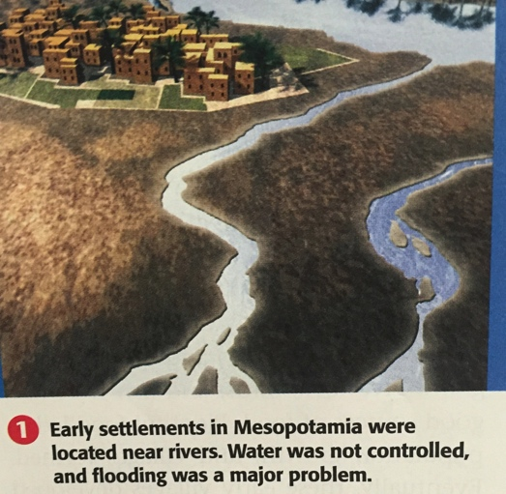
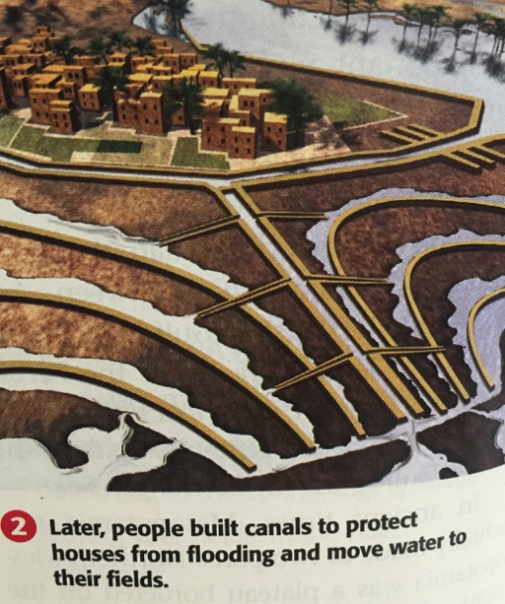

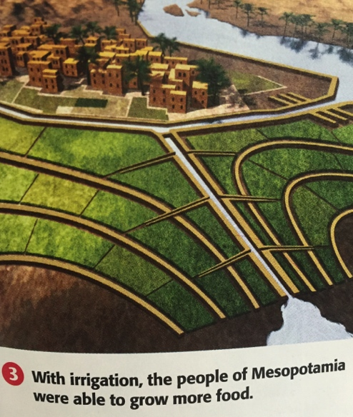

Food Surpluses

Irrigation increased the amount of food farmers were able to grow. In fact, farmers could produce a food surplus, or more than they needed. Farmers also used irrigation to water grazing areas for cattle and sheep. As a result, Mesopotamians ate a variety of foods. Fish, meat, wheat, barley, and dates were plentiful.

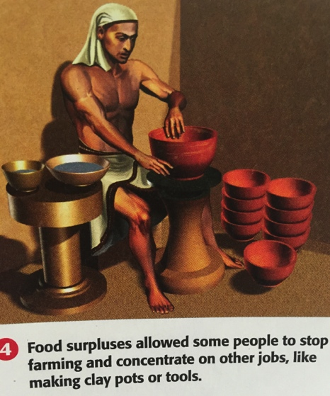

Because irrigation made farmers more productive, fewer people needed to farm. Some people became free to do other jobs. As a result, new occupations developed. For the first time, people became crafters, religious leaders, and government workers. The type of arrangement in which each worker specializes in a particular task or job is called a division of labor
Having people available to work on different jobs meant that society could accomplish more. Large projects, such as constructing buildings and digging irrigation systems, required specialized workers, managers, and organization. To complete these projects, the Mesopotamians needed structure and rules. Structure and rules could be provided by laws and government.

The Appearance of Cities

Over time, Mesopotamian settlements grew in size and complexity. They gradually developed into cities between 4000 and 3000 BCE.
Despite the growth of cities, society in Mesopotamia was still based on agriculture. Most people still worked in farming jobs. However, cities were becoming important places. People traded goods there, and cities provided leaders with power bases. They were political, religious, cultural, and economic centers of civilization.

QUESTIONS:

- Where was Mesopotamia?
- How did the Fertile Crescent get its name?
- What was the most important factor in making Mesopotamia’s farmland fertile?
- Why did farmers need to develop a system to control their water supply?
- In what ways did a division of labor contribute to the growth of Mesopotamian civilization?
- How might running large projects prepare people for running a government?
- Make a list of the words you might use to help young students imagine the land and rivers. Then sketch out a picture or map you could use to show them.

