Name: ________________________

Answer questions on a separate piece of paper or share a Google doc with me.

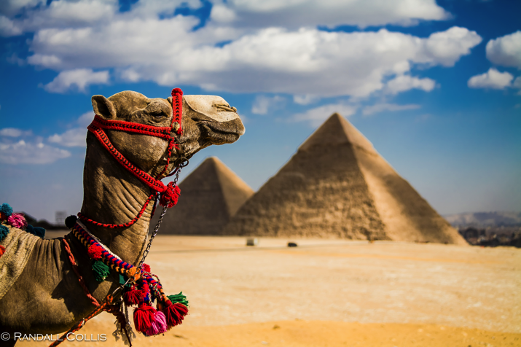

Egypt: Winner of the World’s First mega-State Contest

Egypt is often pictured as the world’s first civilization, but its cities got rolling a little later than Sumer, sometime after 4000 BCE. Still, a couple of hundred years is loose change at this point in human history - and if it’s a contest of size, Egypt wins hands down. Around 3100 BCE it became the world’s first mega- state, unifying over five hundred miles of territory from the Mediterranean Sea to the first cataract (waterfalls) on the Nile River. The pharaohs who ruled Egypt were the most powerful men in the world, and their power lasted far beyond that of the Sumerian kings.
Egypt was unified by a semi-mythical king (or kings) named Menes, who founded the First Dynasty as well as Egypt’s capital, Memphis, just south of the Nile Delta. There are stories of conflict between the people of northern Egypt and southern Egypt, but the Nile united them. Egyptian culture and religion centered on the river, whose rhythms structured Egyptian society for thousands of years. (Currently the giant Aswan Dam controls the floods). During the winter months, snow fell in Ethiopia, where the Nile begins in the mountains. In the spring, when the snow melted, the flood-waters rose to cover the surrounding “flood plains” at the bottom of the Nile Valley, in Egypt. When the Nile finally retreated a month later, it left a thick layer of silt – fertile farmland. This made Egypt the breadbasket of the ancient world.
The Nile could also be incredibly destructive when it flooded, so it’s no surprise that Egyptians believed it had divine power. The Nile was the universe, controlled by gods who required prayers to avert their wrath. The first god was a primordial spirit named Ammon, representing the chaos that existed before the universe was formed. He was an invisible father who held the power of creation – in fact he created himself (ah, paradox). His name means “the Hidden One.” Fittingly, he usually stayed in the background.
Each pharaoh was representative of a single divine spirit, which transmitted itself from pharaoh to pharaoh. This is an important area where Egypt differed from Mesopotamia. In Mesopotamia, the “big man” ruled alongside a high priest, while in Egypt the pharaoh was both ruler and high priest, and living god to boot.
After the pharaoh died he required magnificent funeral rites to ensure his resurrection in the afterlife. The practice of building pyramids as crypts (graves) for dead kings began around 2700 BCE, with the stepped pyramid built for Pharaoh Djoser (Joe-zer) in Saqqara. There were some mishaps along the way. The most famous screw-up is the bent pyramid of Snefru, build at Dahshur around 2600 BCE: apparently the designers realized the sides were too steep halfway through, and reduced the angles dramatically, resulting in the odd eight-sided structure that’s still visible today.

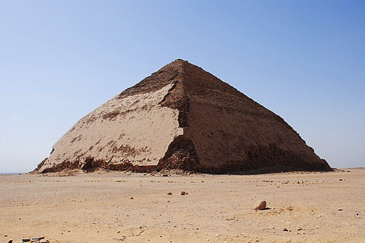

Grave Robbing

Despite the elaborate security precautions, virtually every single tomb in the Egyptian pyramids was looted by grave robbers. And the robbers weren’t just looking for gold and jewels: they wanted it all, meaning dozens of mummies were looted along with their treasures.
At the pyramid of the Pharaoh Khfare (Kah-fre), sacrilegious thieves replaced the mummy with animal bones. Even the “Father of the Pyramids.” Khufu’s Great Pyramid at Giza, was looted – particularly ironic because Khufu had ordered extra security measures for his pyramid after his father’s tomb was robbed. Khufu’s designer, Ankhaf, changed the location of the royal burial chamber midway through the giant project, and included several false or “dummy” chambers to confuse grave robbers.
Robbing pyramids was a large-scale undertaking, calling for hundreds of men to bore through tons of stone. At the pyramid of the Pharaoh Djedefre you can still see the passage grave robbers tunneled through the stone to get at the pharaoh’s burial treasure. A long tunnel at the tomb of Senusret I, whose twists and turns evade granite blocks intended to frustrate robbers, suggests that the robbers were familiar with the pyramid’s design – maybe from an inside source.
The thieves grew bolder as time went on: in the pyramid of Pharaoh Huni, at Meidum, sloppy tomb robbers left behind a small wooden hammer propping up the stone lid of the pharaoh’s sarcophagus. Even more audacious, the thieves who looted the pyramid of Senusret III left behind graffiti depicting themselves on the walls of the royal burial chamber, and apparent taunt to the descendants of the dead pharaoh.
It’s unclear if royal priests were actively involved in the looting of the pyramids, or were merely incompetent. However, there’s some evidence of deceit. When the tomb of Queen Hetepheres, the wife of Snefru, was robbed during the reign of her son Khufu, the priests in charge of reburying the pharaoh’s mother interred an empty casket to cover up the fact that they couldn’t find her body… and they never told Khufu the truth.

Questions:

- How much land was connected once Egypt unified?
- Why do you think the Egyptians’ first kings might have been mythical?
- Why did the Egyptians think the Nile had divine power?
- How do you think the grave robbers were able to get away with their crime (considering it took so many people to commit)?

Geography and Early Egypt

Geography played a key role in the development of Egyptian civilization. The Nile River brought life to Egypt and allowed it to thrive. The river was so important to people in this region that a Greek historian named Herodotus (hi-RAHD-uh-tuhs) called Egypt the gift of the Nile.

Location and Physical Features

The Nile is the longest river in the world. It begins in central Africa and runs north through Egypt to the Mediterranean Sea, a distance of over 4,000 miles. The civilization of ancient Egypt developed along a 750-mile stretch of the Nile.
Ancient Egypt included two regions, a southern region and a northern region. The southern region was called Upper Egypt. It was so named because it was located upriver in relation to the Nile’s flow. Lower Egypt, the northern region, was located downriver. The Nile sliced through the desert of Upper Egypt. There, it created a fertile river valley about 13 miles wide. On either side of the Nile lay hundreds of miles of bleak desert sands.
The Nile flowed through rocky, hilly land south of Egypt. At several points, this rough terrain caused cataracts, or rapids, to form. The first cataract, located 720 miles south of the Mediterranean Sea, marked the southern border of Upper Egypt. Five more cataracts lay father south. These cataracts made sailing on that portion of the Nile very difficult.
In Lower Egypt, the Nile divided into several branches that fanned out and flowed into the Mediterranean Sea. These branches formed a delta, a triangle-shaped area of land made from soil deposited by a river. In ancient times, swamps and marshes covered much of the Nile Delta. Some two-thirds of Egypt’s fertile farmland was located in the Nile Delta.

The Floods of the Nile

Because little rain fell in the region, most of Egypt was desert. Each year, however, rainfall far to the south of Egypt in the highlands of East Africa caused the Nile to flood. The Nile’s floods were easier to predict than those of the Tigris and Euphrates rivers in Mesopotamia. Almost every year, the Nile flooded Upper Egypt in mid-summer and Lower Egypt in the fall.
The Nile’s flooding coated the land around it with a rich silt. As in Mesopotamia, the silt made the soil ideal for farming. The silt also made the land a dark color. That is why Egyptians called their country the black land. They called the dry, lifeless desert beyond the river valley the red land. Each year, Egyptians eagerly awaited the flooding of the Nile. For them, the river’s floods were a life-giving miracle. Without the floods, people never could have farmed in Egypt.

Civilization Develops in Egypt

The Nile provided both water and fertile soil for farming. Over time, scattered farms grew into villages and then cities. Eventually, an Egyptian civilization developed.

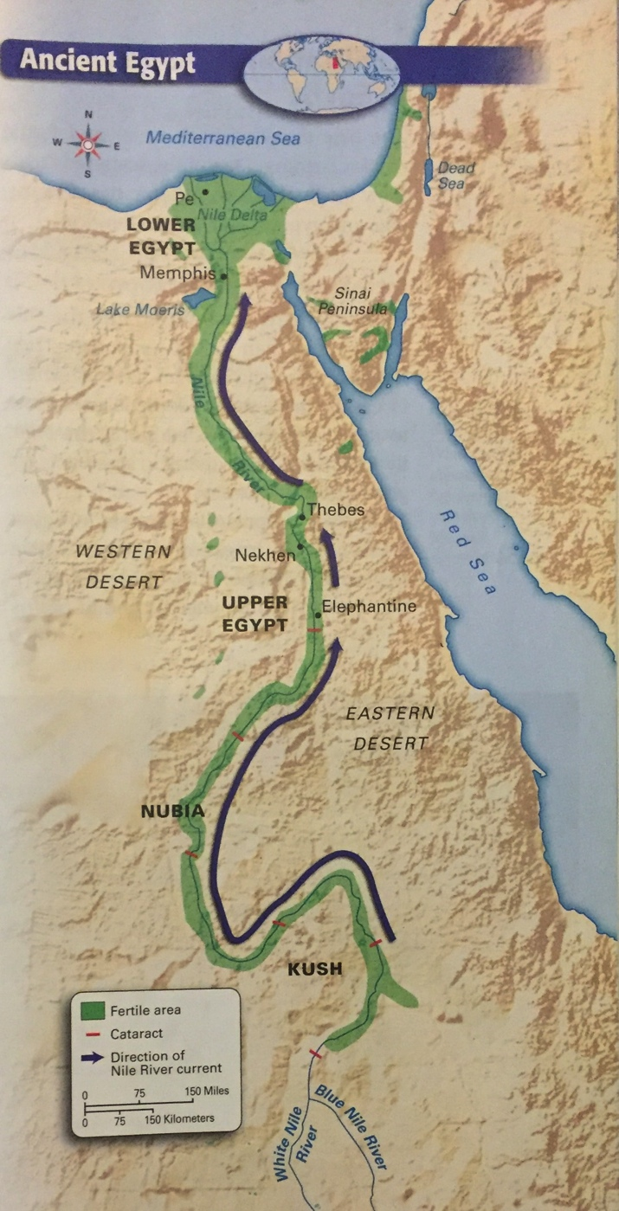

Increased Food Production

Hunter-gatherers first moved into the Nile Valley more than 12,000 years ago. They found plants, wild animals, and fish there to eat. In time, these people learned how to farm, and they settled along the Nile. By 4500 BCE, farmers living in small villages grew wheat and barley.
As in Mesopotamia, farmers in Egypt developed an irrigation system. Unlike farmers in Mesopotamia, however, Egyptian farmers did not need to build basins for storing water. The Egyptian simply built a series of canals to direct the rivers flow and carry water to their fields.
The Nile provided Egyptian farmers with an abundance of food. In addition to watering their crops, the Nile allowed farmers to raise animals. Farmers in Egypt grew wheat, barley, fruits, and vegetables. They also raised cattle and sheep. The river provided many types of fish, and hunters trapped wild geese and ducks along its banks. Like the Mesopotamians, the Egyptians enjoyed a varied diet.

Two Kingdoms

In addition to a stable food supply, Egypt’s location offered another advantage. It had natural barriers that made it hard to invade Egypt. The desert to the west was too big and harsh to cross. To the north, the Mediterranean Sea kept many enemies away. More desert lands and the Red Sea to the east provided protection against invasion as well. In addition, cataracts in the Nile made it difficult for invaders to sail in from the south.
Protected from invaders, the villages of Egypt grew. Wealthy farmers emerged as village leaders, and strong leaders gained control over several villages. By 3200 BCE, the villages had grown, banded together, and developed into two kingdoms. One kingdom was called Lower Egypt, and the other was called Upper Egypt.
Each kingdom had its own capital city where its ruler was based. The capital of Lower Egypt was located in the northwest Nile Delta at a town called Pe. There, wearing the red crown that symbolized his authority, the king of Lower Egypt ruled. The capital city of Upper Egypt was called Nekhen. It was located on the west bank of the Nile. In this southern kingdom, the king wore a cone-shaped white crown. For centuries, Egyptians referred to their country as the two lands.

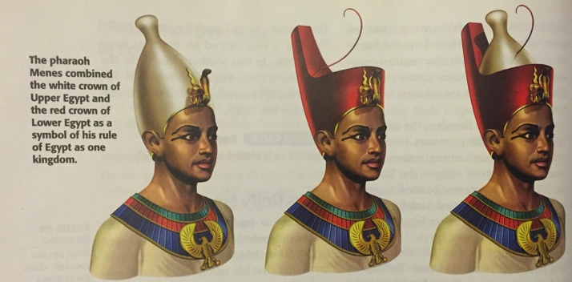
Evolution of Pharaoh’s crown after unification

Kings Unify Egypt

According to tradition, around 3100 BCE Menes (MEE-neez) rose to power in Upper Egypt. Some historians think Menes is a myth and that his accomplishments were really those of other ancient kings named Aha, Scorpion, or Narmer.
Menes wanted to unify Upper and Lower Egypt. His armies invaded and took control of Lower Egypt. He then married a princess from Lower Egypt to strengthen his control over the newly unified country. Menes wore both the white crown of Upper Egypt and the red crown of Lower Egypt to symbolize his leadership over the two kingdoms. Later, he combined the two crowns into a double crown.
Many historians consider Menes to be Egypt’s first pharaoh, the title used by the rulers of Egypt. The title pharaoh means “great house.” Menes also founded Egypt’s first dynasty, or series of rulers from the same family.
Menes built a new capital city at the southern tip of the Nile Delta. The city was later named Memphis. For centuries, Memphis was the political and cultural center of Egypt. Many government offices were located there, and the city bustled with artistic activity.
The First Dynasty lasted for about 200 years. Rulers who came after Menes also wore the double crown to symbolize their rule over Upper and Lower Egypt. They extended Egyptian territory southward along the Nile and into Southwest Asia. Eventually, however, rivals arose to challenge the First Dynasty for power. These challengers took over Egypt and established the Second Dynasty.

Questions:

- Why was the Nile Delta well suited for settlement?
- How might the Nile’s cataracts have both helped and hurt Egypt?
- How did the desert on both sides of the Nile help ancient Egypt?
- Why did the pharaohs of the First Dynasty wear a double crown?

Life in the Old Kingdom

The First and Second Dynasties ruled Egypt for about four centuries. Around 2700 BCE, though, a new dynasty rose to power in Egypt. Called the Third Dynasty, its rule began a period in Egyptian history known as the Old Kingdom.

Early Pharaohs

The Old Kingdom was a period in Egyptian history that lasted for about 500 years, from about 2700 to 2200 BCE. During this time, the Egyptians continued to develop their political system. The system they developed was based on the belief that the pharaoh, the ruler of Egypt, was both a king and a god.
The ancient Egyptians believed that Egypt belonged to the gods. They believed that the pharaoh had come to earth in order to manage Egypt for the rest of the gods. As a result, he had absolute power over all land and people in Egypt.
But the pharaoh’s status as both king and god came with may responsibilities. People blamed him if crops did not grow well or if disease struck. They also demanded that the pharaoh make trade profitable and prevent wars.
The most famous pharaoh of the Old Kingdom was Khufu (KOO-foo), who ruled in the 2500s BCE. Even though he is famous, we know relatively little about Khufu’s life. Egyptian legend says that he was cruel, but historical records tell us that the people who worked for him were well fed. Khufu is best known for the monuments that were built to him.

Society and Trade

By the end of the Old Kingdom, Egypt had about two million people. As the population grew, social classes appeared. The Egyptians believed that a well-ordered society would keep their kingdom strong.
At the top of the Egyptian society was the pharaoh. Just below him were the upper classes, which included priests and key government officials. Many of these priests and officials were nobles, or people from rich and powerful families.
Next in society was the middle class. It included lesser government officials, scribes, and a few rich craftspeople.

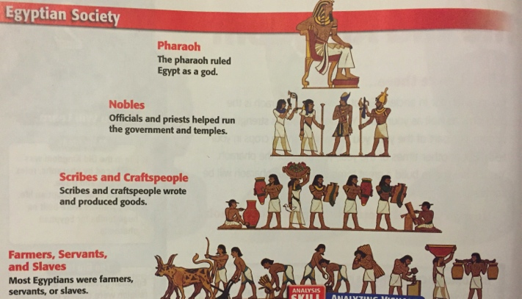
Social Hierarchy in Egypt

The people in Egypt’s lower class, more than 80 percent of the population, were mostly farmers. During flood season, when they could not work in the fields, farmers worked on the pharaoh’s building projects. Servants and slaves also worked hard.
As society developed during the Old Kingdom, Egypt traded with some of its neighbors. Traders traveled south along the Nile to Nubia to acquire gold, copper, ivory, slaves, and stone for building. Trade with Syria provided Egypt with wood for building and for fire.
Egyptian society grew more complex during this time. It continued to be organized, disciplined, and highly religious.

Religion and Egyptian Life

Worshiping the gods was a part of daily life in Egypt. But the Egyptian focus on religion extended beyond people’s lives. Many customs focused on what happened after people died.

The Gods of Egypt

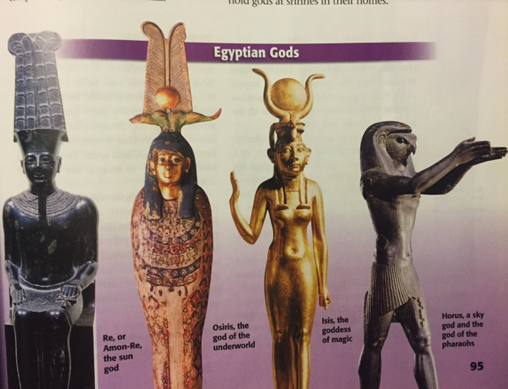

The Egyptians practiced polytheism. Before the First Dynasty, each village worshipped its own gods. During the Old Kingdom, however, Egyptian officials expected everyone to worship the same gods, though how they worshipped the gods might differ from place to place.
The Egyptians built temples to the gods all over the kingdom. Temples collected payments from both worshippers and the government. These payments allowed the temples to grow more influential.
Over time, certain cities became centers for the worship of certain gods. In the city of Memphis, for example, people prayed to Ptah, the creator of the world.
The Egyptians worshipped many gods besides Ptah. They had gods for nearly everything, including the sun, the sky, and the earth. Many gods mixed human and animal forms. For example, Anubis, the god of the dead, had a human body but a jackal’s head. Other major gods included
- Re, or Amon-Re, the sun god
- Osiris, the god of the underworld
- Isis, the goddess of magic
- Horus, a sky god, god of pharaohs
- Thoth, the god of wisdom
- Geb, the earth god
Egyptian families also worshipped household gods at shrines in their homes.

Emphasis on the Afterlife

Much of Egyptian religion focused on the afterlife, or life after death. The Egyptians believed that the afterlife was a happy place. Paintings from Egyptian tombs show the afterlife as an ideal world where all the people are young and healthy.
They Egyptians belief in the afterlife stemmed from their idea of ka (KAH), or a person’s life force. When a person died, his or her ka left the body and became a spirit. The ka remained linked to the body and could not leave its burial site. However, it had all the same needs that the person had when he or she was living. It needed to eat, sleep, and be entertained.
To fulfill the ka’s needs, people filled tombs with objects for the afterlife. These objects included furniture, clothing, tools, jewelry, and weapons. Relatives of the dead were expected to bring food and beverages to their loved ones’ tombs so the ka would not be hungry or thirsty.

Burial Practices

Egyptian ideas about the afterlife shaped their burial practices. The Egyptians believed that a body had to be prepared for the afterlife before it could be placed in a tomb. This meant the body had to be preserved. If the body decayed, its spirit could not recognize it. That would break the link between the body and spirit. The ka would then be unable to receive the food and drink it needed.
To keep the ka from suffering, the Egyptians developed a method called embalming to preserve bodies and keep them from decaying. The Egyptians preserved bodies as mummies, specially treated bodies wrapped in cloth. Embalming preserves a dead body for many, many years. A body that was not embalmed would decay quickly in a tomb.
Embalming was a complex process that took several weeks to complete. In the first step, embalmers cut open the body and removed all the organs except for the heart. The removed organs were stored in special jars. Next, embalmers used a special substance to dry out the body and later applied some special oils. The embalmers then wrapped the dried-out body with linen cloths and bandages, often placing special charms inside the cloth wrappings. Wrapping the body was the last step in the mummy-making process. Once it was completely wrapped, a mummy was placed in a coffin.
Only royalty and other members of Egypt’s elite, or people of wealth and power, could afford to have mummies made. Peasant families did not need the process, however. They buried their dead in shallow graves at the edge of the desert. The hot, dry sand of the desert preserved the bodies naturally.

The Pyramids

The Egyptians believed that burial sites, especially royal tombs, were very important. As a result, they built spectacular monuments in which to bury their rulers. The most spectacular of all were the pyramids – huge, stone tombs with four triangle-shaped sides that met in a point on top.
The Egyptians first built pyramids during the Old Kingdom. Some of the largest pyramids ever constructed were build during this time. Many of these huge pyramids are still standing. The largest is the Great Pyramid of Khufu near the town of Giza. It covers more than 13 acres at its base and stands 481 feet high. This single pyramid took thousands of workers and more than two million limestone blocks to build. Like all the pyramids, it is an amazing reminder of Egyptian engineering, the application of scientific knowledge for practical purposes.

Building the Pyramids

The earliest pyramids did not have the smooth sides we usually imagine when we think of pyramids. The Egyptians began building the smooth-sided pyramids we usually see around 2700 BCE. The steps of these pyramids were filled and covered with limestone. The burial chamber was deep inside the pyramid. After the pharaoh’s burial, workers sealed the passages to this room with large blocks.
Historians are not sure how the Egyptians built the pyramids. What is certain is that such enormous projects required a huge labor force; as many as 100,000 workers may have been needed to build a single pyramid. The government kept records and paid the peasants for their work. Wages for working on construction projects, however, were pained in goods such as grain instead of money.
For years, scholars have debated how the Egyptians moved the massive stones used to build the pyramids. Some believe that during the Nile’s flooding, builders floated the stones downstream directly to the construction site. Most historians believe that workers used brick ramps and strong sleds to drag the stones up the pyramid once they reached the site.

Significance of the Pyramids

Burial in a pyramid demonstrated a pharaoh’s importance. The size and shape of the pyramid were symbolic. Pointing to the skies, the pyramid symbolized the pharaoh’s journey to the afterlife. The Egyptians wanted the pyramids to be spectacular because they believed that the pharaoh, as their link to the gods, controlled everyone’s afterlife. Making the pharaoh’s spirit happy was a way of ensuring one’s own happy afterlife.
To ensure that pharaohs remained safe after their deaths, the Egyptians sometimes wrote magical spells and hymns on the pharaohs’ tombs. Together, these spells and hymns are called Pyramid Texts. The first such text, addressed to Re, was carved into the pyramid of King Unas a pharaoh of the Old Kingdom:

Re, this Unas comes to you,
A spirit indestructible…
Your son comes to you, this Unas…
May you cross the sky united in the dark,
May you rise in lightland, [where] you shine!

The builders of Unas’s pyramid wanted the god to look after their leader’s spirit. Even after death, their pharaoh was important to them.

Questions:
- What does Old Kingdom refer to?
- Why was the pharaoh’s authority never questioned?
- Why was embalming important to Egyptians?
- What does the building of the pyramids tell us about Egyptian society?

The Middle and New Kingdoms

The Middle Kingdom

At the end of the Old Kingdom, the wealth and power of the pharaohs declined. Building and maintaining pyramids cost a lot of money. Pharaohs could not collect enough taxes to keep up with their expenses. At the same time, ambitious nobles used their government positions to take power from pharaohs.
In time, nobles gained enough power to challenge the pharaohs. By about 2200 BCE the Old Kingdom had fallen. For the next 160 years, local nobles ruled much of Egypt. The kingdom had no central ruler.
Finally, around 2050 BCE, a powerful pharaoh defeated his rivals, and once again all of Egypt was united. His rule began the Middle Kingdom, a period of order and stability which lasted to about 1750 BCE. Toward the end of the Middle Kingdom, however, Egypt began to fall into disorder once more.
Around 1750 BCE, a group from South-west Asia called the Hyskos (HIK-sohs) invaded. They used horses, chariots, and advanced weapons to conquer Lower Egypt. The Hyksos ruled the region as pharaohs for 200 years.
The Egyptians eventually fought back, however. In the mid-1500s BCE, Ahmose (AHM-ohs) of Thebes declared himself king and drove the Hyksos out of Egypt. Ahmose then ruled all of Egypt.

The New Kingdom

Ahmose’s rise to power marked the beginning of Egypt’s eighteenth dynasty. More importantly, it was the beginning of the New Kingdom, the period during which Egypt reached the height of its power and glory. During the New Kingdom, which lasted from about 1550 to 1050 BCE, conquest and trade brought wealth to the pharaohs.

Building an Empire

After battling the Hyksos, Egypt’s leaders feared future invasions. To prevent such invasions from occurring, they decided to take control of all possible invasion routes into the kingdom. In the process, these leaders turned Egypt into an empire.
Egypt’s first target was the homeland of the Hyksos. After taking over that area, the army continued north and conquered Syria. As you can see from the map, Egypt took over the entire eastern shore of the Mediterranean and the kingdom of Kush, south of Egypt. By the 1400s BCE, Egypt was the leading military power in the region. Its empire extended from the Euphrates River the southern Nubia.
Military conquests made Egypt rich. The kingdoms it conquered regularly sent treasures to their Egyptian conquerors. For example, the kingdom of Kush in Nubia south of Egypt sent annual payments of gold, leopard skins, and precious stones to the pharaohs. In addition, Assyrian, Babylonian, and Hittite kings sent expensive gifts to Egypt in an effort to maintain good relations.

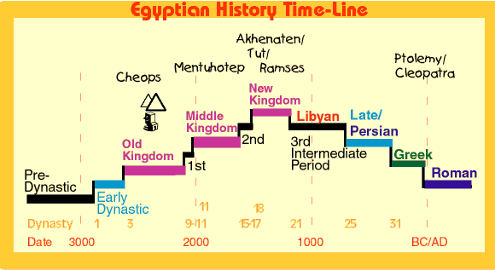

Growth and Effects of Trade

Conquest also brought Egyptian traders into contact with more distant lands. Egypt’s trade expanded along with its empire. Profitable trade routes, or path followed by traders, developed. Many of the lands that Egypt took over also had valuable resources for trade. The Sinai Peninsula, for example, had large supplies of turquoise and copper.
One ruler who worked to increase Egyptian trade was Queen Hatshepsut. She sent Egyptian traders south to trade with the kingdom of Punt on the Red Sea and north to trade with people in Asia Minor and Greece.
Hatshepsut and later pharaohs used the money they gained from trade to support the arts and architecture. Hatshepsut especially is remembered for the many impressive monuments and temples built during her reign. The best known of these structures was a magnificent temple built for her near the city of Thebes.

Invasions of Egypt

Despite its great successes, Egypt’s military might did not go unchallenged. In the 1200s BCE the pharaoh Ramses II, or Ramses the Great, fought the Hittites, a group from Asia Minor. The two powers fought fiercely for years, but neither could defeat the other.
Egypt faced threats in other parts of its empire as well. To the west, a people known as the Tehenu invaded the Nile Delta. Ramses fought them off and built a series of forts to strengthen the western frontier. This proved to be a wise decision because the Tehenu invaded again a century later. Faced with Egypt’s strengthened defenses, the Tehenu were defeated once again.
Soon after Ramses the Great died, invaders called the Sea Peoples sailed into Southwest Asia. Little is known about these people. Historians are not even sure who they were. All we know is that they were strong warriors who had crushed the Hittites and destroyed cities in Southwest Asia. Only after fifty years of fighting were the Egyptians abe to turn them back.
Egypt survived, but its empire in Asia was gone. Shortly after the invasions of the Hittites and the Sea Peoples, the New Kingdom came to an end. Egypt fell into a period of violence and disorder. Egypt would never regain its power.

Work and Daily Life

Although Egyptian dynasties rose and fell, daily life for Egyptians did not change very much. But as the population grew, society became even more complex.
A complex society requires people to take on different jobs. In Egypt, these jobs were usually passed on within families. At a young age, boys started to learn their future jobs from their fathers.

Scribes

Other than priests and government officials, no one in Egypt was more honored than scribes. As members of the middle class, scribes worked for the government and the temples. They kept records and accounts for the state. Scribes also wrote and copied religious and literary texts, including stories and poems. Because they were so respected, scribes did not have to pay taxes, and many became wealthy.

Artisans, Artists, and Architects

Another group in society was made up of artisans whose jobs required advanced skills. Among the artisans who worked in Egypt were sculptors, builders, carpenters, jewelers, metalworkers, and leatherworkers. Most of Egypt’s artisans worked for the government or for temples. They made statues, furniture, jewelry, pottery, shoes, and fairly well for their work.
Architects and artists were also admired in Egypt. Architects designed the temples and royal tombs for which Egypt is famous. Talented architects could rise to become high government officials. Artists, often employed by the state or the temples, produced many different works. Artists often worked in the deep burial chambers of the pharaohs’ tombs painting detail pictures.

Merchants and Traders

Although trade was important to Egypt, only a small group of Egyptians became merchants and traders. Some traveled long distances to buy and sell goods. Merchants were usually accompanied by soldiers, scribes, and laborers on their travels.

Soldiers

After the wars of the Middle Kingdom, Egypt created a professional army. The military offered people a chance to rise in social status. Soldiers received land as payment and could also keep any treasure they captured in war. Those who excelled could be promoted to officer positions.

Farmers and Other Peasants

As in Old Kingdom society, Egyptian farmers and other peasants were toward the bottom of Egypt’s social scale. These hard-working people made up the vast majority of Egypt’s population.
Farmers grew crops to support their families. Farmers depended on the Nile’s regular floods to grow their crops. They used wooden hoes or plows pulled by cows to prepare the land before the flood. After the floodwaters had drained away, farmers plated seeds. They grew crops such as wheat and barley. At the end of the growing season, farmers worked together to gather the harvest.
Farmers had to give crops to the pharaoh as taxes. These taxes were intended to pay the pharaoh for using the land. Under Egyptian law, the pharaoh controlled all land in the kingdom.
All peasants, including farmers, were also subject to special duty. Under Egyptian law, the pharaoh could demand at any time that people work on projects, such as building pyramids, mining gold, or fighting in the army. The government paid the workers in grain.

Slaves

The few slaves in Egyptian society were considered lower than farmers. Many slaves were convicted criminals or prisoners captured in war. They worked on farms, on building projects, in workshops, and in private households. Unlike most slaves in history, however, slaves in Egypt had some legal rights. Also, in some cases, they could earn their freedom.

Family Life in Egypt

Family life was important in Egyptian society. Most Egyptian families lived in their own homes. Sometimes unmarried female relatives lived with them, but men were expected to marry young so that they could start having children.
Most Egyptian women were devoted to their homes and their families. Some, however, had jobs outside the home. A few served as priestesses, and some worked as royal officials, administrators, and artisans. Unlike most ancient women, Egyptian women had a number of legal rights. They could own property, make contracts, and divorce their husbands. They could even keep their property after a divorce.
Children’s lives were not as structured as adults’ lives were. They played with toys such as dolls, tops, and clay animal figurines. Children also played ballgames and hunted. Most children, boys and girls, received some education. At school they learned morals, writing, math, and sports. At age fourteen most boys left school to enter their father’s profession. At that time, they took their place in Egypt’s social structure.

Questions:

- What was the Middle Kingdom?
- How did Ahmose manage to become king of all Egypt?
- What did Hatshepsut do as pharaoh of Egypt?
- Why do you think scribes were so honored in Egyptian society?

Egyptian Achievements

Egyptian Writing

If you were reading a book and saw pictures of folded cloth, a leg, a star, a bird, and a man holding a stick, would you know what it meant? You would if you were an ancient Egyptian. In the Egyptian writing system, or hieroglyphics, those five symbols together meant, “to teach.” Egyptian hieroglyphics were one of the world’s first writing systems.

Writing in Ancient Egypt

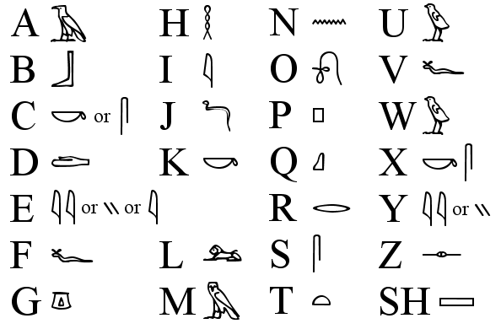

The earliest known examples of Egyptian writing are from around 3300 BCE. These early Egyptian writings were carved in stone or on other hard material. Later, the Egyptians learned how to make papyrus, a long-lasting, paper-like material made from reeds. The Egyptians made papyrus by pressing layers of reeds together and pounding them into sheets. These sheets were tough and durable, yet easy to roll into scrolls. Scribes wrote on papyrus using brushes and ink. The hieroglyphic writing system used more than 600 symbols, mostly pictures of objects. Each symbol represented one or more sounds in the Egyptian language. For example, a picture of an owl represented the same sound as our letter M.
Hieroglyphics could be written either horizontally or vertically. They could be written from right to left or form left to right. These options made hieroglyphics flexible to write but difficult to read. The only way to tell which way a text is written is to look at individual symbols.

The Rosetta Stone

Historians and archaeologists have known about hieroglyphics for centuries, but for a long time they didn’t know how to read it. In fact, it was not until 1799 when a lucky discovery by a French soldier gave historians the key they needed to read ancient Egyptian writing.

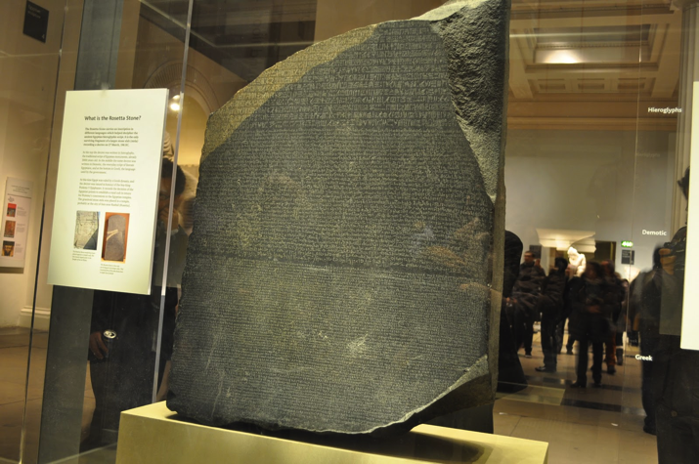
Rosetta Stone located at the British Museum

That key was the Rosetta Stone, a huge, stone slab inscribed with hieroglyphics. In addition to the hieroglyphics, the Rosetta Stone had text in Greek and a later form of Egyptian. Because the text in all three languages was the same, scholars who knew Greek were able to figure out what the hieroglyphics said.

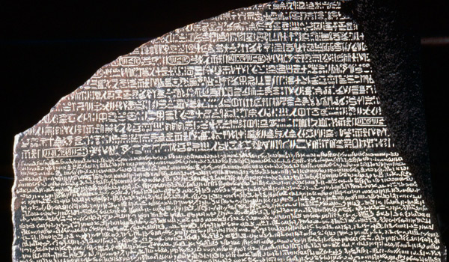
Check out the different forms of writing!

Egyptian Texts

Because papyrus did not decay in Egypt’s dry climate, many Egyptian texts still survive. Historians today can read Egyptian government records, historical records, science texts, and medical manuals. In addition, many literary works have survived. Some, such as The Book of the Dead, tell about the afterlife. Others tell stories about gods and kings.

Egypt’s Great Temples

In addition to their writing system, the Egyptians are famous today for their magnificent architecture. You have already read about the Egyptians’ most famous structures, the pyramids. But the Egyptians also built massive temples. Those that survive are among the most spectacular sites in Egypt today.
The Egyptians believed that temples were the homes of the gods. People visited the temples to worship, offer the gods gifts, and ask for favors.
Many Egyptians believed that temples were the homes for the gods. Rows of stone sphinxes imaginary creatures with the bodies of lions and the heads of other animals or humans – lined the path leading to the entrance. That entrance itself was a huge, thick gate. On either side of the gate might stand an obelisk, a tall, four-sided pillar that is pointed on top.

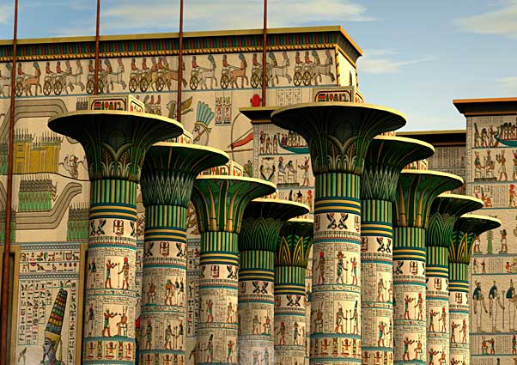
Columns of Karnak

Inside, the temples were lavishly decorated. Huge columns supported the temple’s roof. In many cases, these columns were covered with paintings and hieroglyphics, as were the temple walls. Statues of gods and pharaohs often stood along the walls as well. The sanctuary, the most sacred part of the building, was at the far end of the temple.
The Temple of Karnak is only one of Egypt’s great temples. Others were built by Ramses the Great at Abu Simbel and Luxor. The temple at Abu Simbel is especially known for the massive statues that stand next to its entrance. The 66-foot-tall statues, carved out of sandstone cliffs, show Ramses the Great as pharaoh. Nearby are some smaller statues of his family.

Egyptian Art

One reason Egypt’s temples are so popular with tourists is the art they contain. The ancient Egyptians were masterful artists. Many of their greatest works were created to fill the tombs of pharaohs and other nobles. The Egyptians took great care in making these items because they believed the dead could enjoy them in the afterlife.

Paintings

Egyptian art was filled with lively, colorful scenes. Detailed works covered the walls of temples and tombs. Artists also painted on canvas, papyrus, pottery plaster, and wood. Most Egyptians, however, never saw these paintings. Only kings, priests, and important people could enter temples and tombs, and even they rarely entered the tombs.
The subjects of Egyptian paintings vary widely. Some paintings show important historical events, such as the crowning of kings and the founding of temples. Others illustrate major religious rituals. Still other paintings show scenes from everyday life, such as farming or hunting.
Egyptian painting has a distinctive style. People, for example, are drawn in a certain way. In Egyptian paintings, people’s heads and legs are always seen from the side, but their upper bodies and shoulders are shown straight on. In addition, people do not all appear the same size. Important figures such as pharaohs appear huge in comparison to others, especially servants or conquered people. In contrast, Egyptian animals were usually drawn realistically.
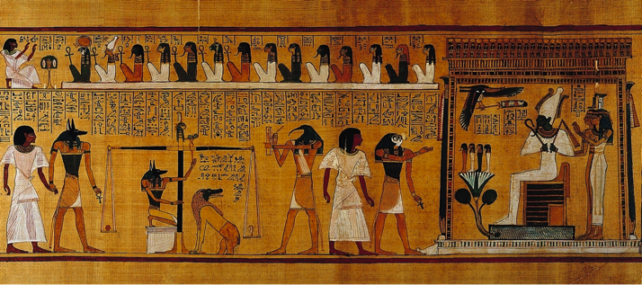
Last Judgment of Hu-Nefer (judging his soul for the afterlife)
Carvings and Jewelry

Painting was not the only art form Egyptians practiced. The Egyptians were also skilled stoneworkers. Many tombs included huge statues and detailed carvings.
The Egyptians also made beautiful objects out of gold and precious stones. They made jewelry for both women and men. This jewelry included necklaces, collars, and bracelets. The Egyptians also used gold to make burial items for their pharaohs.
Over the years, treasure hunters emptied many pharaohs’ tombs. At least one tomb, however, was not disturbed. In 1922 some archaeologists found the tomb of King Tutankhamen or King Tut. The tomb was filled with treasures, including boxes of jewelry, robes, a burial mask, and ivory statues. King Tut’s treasures have taught us much about Egyptian burial practices and beliefs.

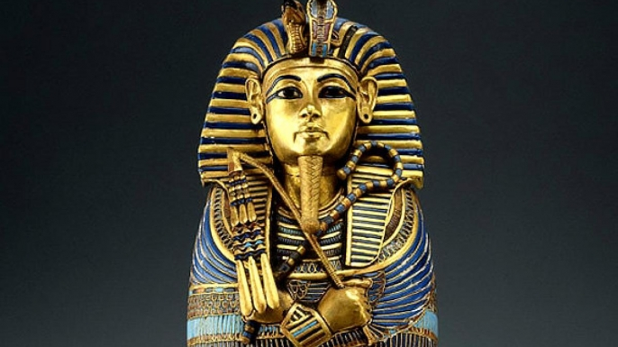
King Tutankhamen’s Death Mask

Questions:
- What are hieroglyphics?
- How was hieroglyphic writing different from our writing today?
- What were two ways the Egyptian’s decorated their temples?
- Draw a chart like the one below. In each column, write a statement that summarizes Egyptian achievements in the appropriate category.
Writing | Architecture | Art

